Liquibase

How Liquibase Works

There are two main mechanisms, or concepts, that are the foundation of Liquibase. These two concepts are:
- Schema Changes which consist of changelogs, changesets, and Change Types.
- Tracking tables that record database changes.

 Schema Changes
Schema changes are the fundamental unit of change in Liquibase. In SQL, schema changes are written using SQL statements that create, modify, or drop database objects. Examples of typical schema changes are create table, add index, and drop column. In XML, YAML, or JSON, the same schema changes are modeled as Liquibase Change Types.
- One or more schema changes (Change Types) are grouped into a changeset. The best practice is to limit each changeset to only one Change Type.
- One or more changesets are contained in a changelog.
- Changelogs are text files containing schema changes. They should be stored and versioned in your preferred source control tool.
In addition to containing schema changes, a changelog can include other changelogs. This allows multiple teams to each work on their own changelogs so they can work independently.
Creating, writing, and editing changelogs and their changesets will be covered in more detail later in the course.

Tracking Tables
Tracking tables are used to track, version, and deploy database schema changes. If your database does not contain a tracking table, Liquibase will create one for you.
Liquibase uses two types of tables to track successful schema change deployments:
- DATABASECHANGELOG
- DATABASECHANGELOGLOCK
DATABASECHANGELOG tracks each changeset in the changelog by id, author, and the file where the changeset resides. The composite of “id”, “author”, and “filename” is unique across all rows of the table.
DATABASECHANGELOGLOCK ensures only one instance of Liquibase is running at one time. It locks others out to prevent multiple Liquibase commands from being executed at the same time which could cause database conflicts. This assists in keeping other Devs, DBA's, or teams from overwriting your changes accidentally.

Liquibase Terminology
It is important to understand Liquibase terminology. Some of these you may already know and some you may be seeing for the first time. The list below includes the most common terms not only for this course but also when using Liquibase in your day-to-day operations.
- Project - a collaborative enterprise that is carefully planned and designed to achieve a particular aim.
- Database - an organized collection of data, generally stored and accessed electronically from a computer system.
- Command Line Interface (CLI) - a text-based interface that allows you to view and modify your files. The CLI allows you to enter a variety of Liquibase commands in a text-based format.
- Changelog - acts as a ledger of changes and contains a list of changesets (units of change) that Liquibase can execute on a database.
- Changeset - a unit of change that occurs to a database and is indicated by a changeset tag <changeset> in XML or --changeset author:id in SQL. The changeset tag contains that unit of change (which is specified by a change type - or the type of change you want to make) and is identified by the id tag, author tag, and changelog file classpath name.

Liquibase Commands
Below are common commands used when working with Liquibase. They include:
- update - applies to all unrun changes.
- rollback - reverts (rolls back) changes you have made to your database.
- snapshot - used when you want to quickly compare changes in your database or keep a record of your current database state.
- dbDoc - generates database change documentation.
- diff - allows you to compare two databases of the same type or different types to one another.
- diffChangeLog - used when you want to create a deployable changelog to synchronize multiple databases.
- generateChangeLog - creates a changelog file that has a sequence of changesets which describes how to re-create the current state of the database.
- rollbackOneChangeSet - reverts (rolls back) one non-sequential changeset made during a previous change to your database.
- rollbackOneUpdate - reverts (rolls back) all changesets related to a specific deploymentId made during a previous change to your database.
- rollbackOneUpdateSql - a helper command that allows you to inspect the SQL Liquibase will run to revert all changesets associated with the deploymentID specified in the rollbackOneUpdate command.
- rollbackOneChangeSetSql - a helper command that allows you to inspect the SQL Liquibase will run to revert the changeset specified in the rollbackOneChangeSet.
- history - a helper command that lists out all your deploymentIds and all changesets associated with each deploymentId.

Congratulations, you have just successfully completed the course introduction! Select Complete and continue to advance to the knowledge check. We will ask a couple of multiple-choice questions and then you will be on your way to Module 1.
Test:
CORRECT

You have learned that Liquibase is a database migration tool that tracks, versions, and deploys database schema changes. Liquibase also provides full control of how database changes are deployed.

From the available answers, which is NOT a feature of Liquibase.
Can merge changes from multiple developers
Supports multiple databases
Uses tracking tables
Creates changelogs that are generated for new databases only
Liquibase can also generate starting changelogs for existing databases.

CORRECT

A DATABASECHANGELOGLOCK is a type of tracking table that makes sure that updates to the same database schema at the same time are prohibited.
True
False

CORRECT

From the answers provided, what best describes a "rollback".
Reverts one non-sequential changeset made during a previous change to the database
Reverts all changesets related to a specific deployment ID
Ability to undo changes made to the database
A helper command that lists all database changes that have been reverted

CORRECT

A changeset is a text file of schema changes in SQL, XML, YAML or JSON.
True
False
changesets are units of change that include objects which Liquibase converts into Change Types.

Module 1 Overview
For this module, we will focus our attention on installing and configuring Liquibase. We will explain the different installation methods and explore configuration with liquibase.properties files.

Objectives
By the end of this module you will be able to:
- Understand Liquibase prerequisites
- Choose one installation method and install the software onto your computer
- Locate and configure the liquibase.properties file
- Know how to solve common installation issues

 Module To Do List
Try to complete these tasks in the following order:
- Watch all videos and read all course materials associated with this module.
- Complete an installation and configuration activity.
- Complete the knowledge check at the end of this module.

Select Complete and continue to learn about installing Liquibase.
Liquibase Installation Overview
Liquibase is built to work with different operating systems. For this module, we will be focusing on how to install Liquibase for Windows and Mac operating systems. If you are using Linux or Unix operating system, follow the directions for the Mac installation.

Important - This course requires the use of database to practice using Liquibase commands. If you currently have Liquibase installed, DO NOT use your production database for any of the module tutorials and activities.

The Liquibase installer method used in this module provides an H2 example database that can be used throughout the course. It can be found in the \liquibase\example directory. Otherwise, you can use your own DEV or TEST database.

 Methods to Install Liquibase
There are two primary methods to install Liquibase:
- Using the Liquibase installer.
- Downloading and unzipping/untarring the Liquibase files.
Both of these methods will vary slightly depending on your operating system.
The Liquibase installer is available for both Windows and Mac systems. It includes everything you need to run Liquibase including Java files, example database and drivers, and examples of SQL and XML files to help you learn Liquibase quickly.

Note: There are other local installation methods that we will not be covered in this course. If you are interested in learning more, visit the Liquibase Software Download page.

If you encounter an issue during installation, please perform these 3 steps to verify that Liquibase is successfully installed on your system:
- Check the path - verify that the Liquibase folder was correctly added to your System PATH Variable.
- Ensure Java is installed - Liquibase will not run without Java.
- Run the help command - this command verifies that Liquibase is up and running correctly.
We will go into more detail concerning these troubleshooting steps in a separate tutorial.

Using GitHub Actions to Learn Liquibase
There may be instances when you may be prohibited, or do not want to install software locally.
To make it easy to learn Liquibase without installing the software, a GitHub Actions repository has been created.
- It contains all the necessary files to set up workflows including an H2 database, changelog files, and the liquibase.properties file.
- There are also several pre-built workflows ready to be used.
For more information on how to learn how to use the Liquibase GitHub Actions, visit the GitHub Action Workflow support page.

Select Complete and continue to get started with your Liquibase installation.
Liquibase Installer for Windows, Mac|Linux|Linux

The Liquibase Installer comes with everything you need to get Liquibase up and running. This includes Java, directories, property files, drivers, and examples. This section will help you understand the core concepts of Liquibase and learn the Liquibase Developer Workflow using a sample database.

Note: If you are using a Linux or Unix operating system, follow the directions for the Mac installation.

Downloading the Liquibase Installer for Windows and Mac|Linux|Unix
- Go to https://www.liquibase.org.
- Click the  button.
- Enter your email address and select the  button.
  - This will send an email that contains a link to the Getting Started with Liquibase page.
- You will see the Liquibase download page. Make sure the correct tab for your operating system is selected.
 or 
- Navigate to the section for the "latest stable release". Select the <version> Installer.
- Select the installer link to download the Liquibase installer.
Note to Mac users: To install Liquibase using the installer method requires sudo permissions. If you DO NOT have sudo permissions, you can manually install Liquibase by following the instructions by selecting Installing Liquibase command line for Linux/Unix/Mac

 Running the Liquibase Installer for Windows
Navigate to the location where the executable was saved and select the executable file to start. The steps listed below represent an installation on a local machine:

1. Run the installer.

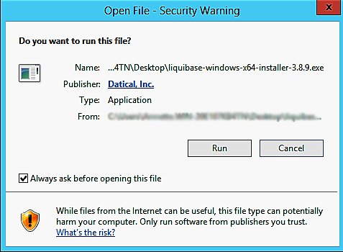

2. Select Next to start the setup wizard.

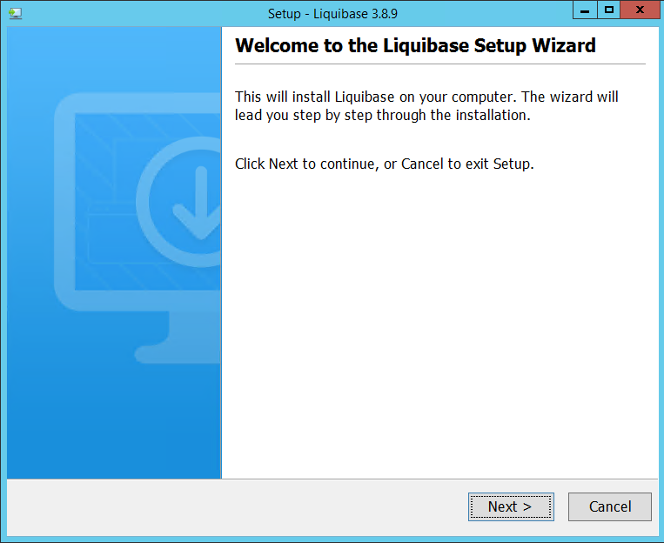

3. Use the default folder \Program Files\liquibase.
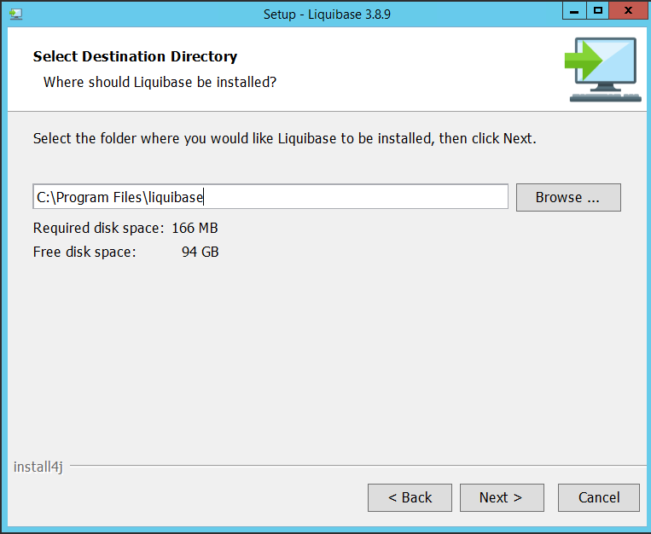

4. Use the default Add Liquibase to PATH.

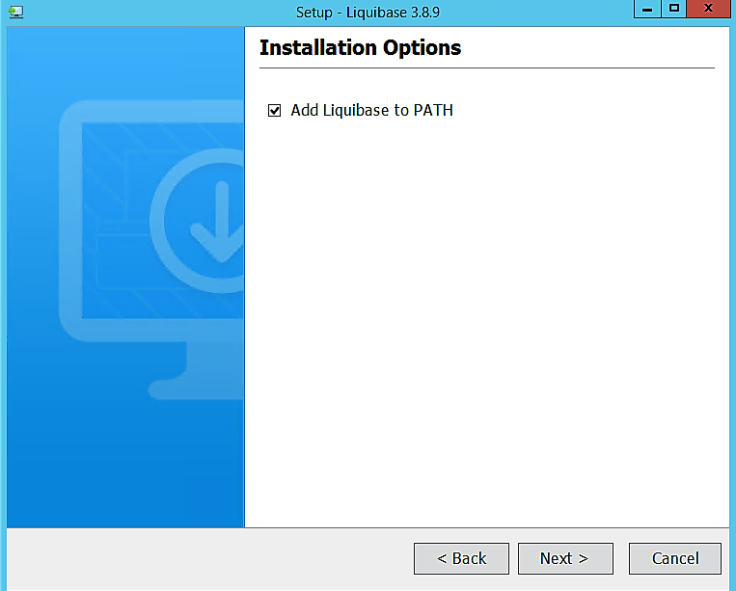

5. Complete the Liquibase installation by selecting Finish.

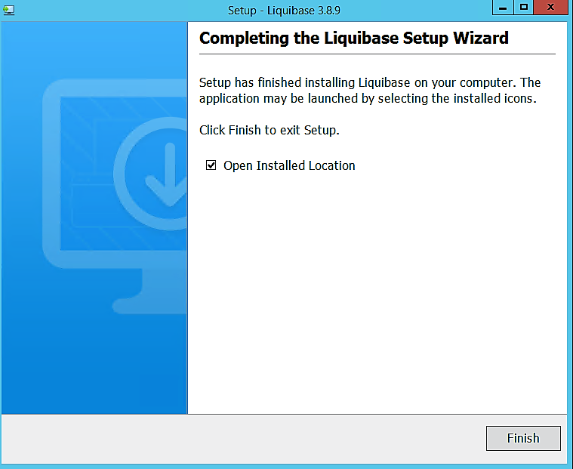

What was installed for Windows

If you selected the default, the Liquibase folder was installed in C:\Program Files\liquibase and it contains the following directories and files:
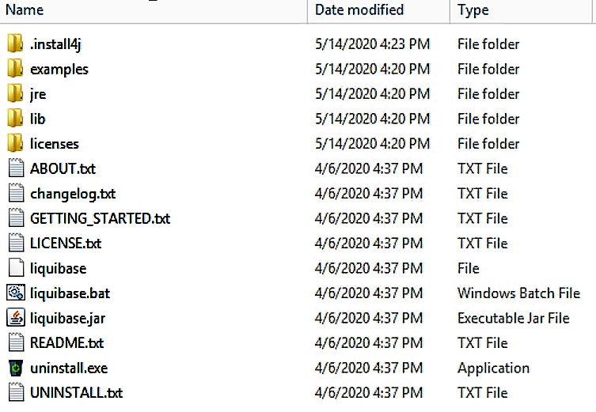

Running the Liquibase Installer for Mac

Navigate to the location where the installer app was saved.

1. Double-click the downloaded installer file to begin.

If you see the following message when you double-click the installer, click OK.

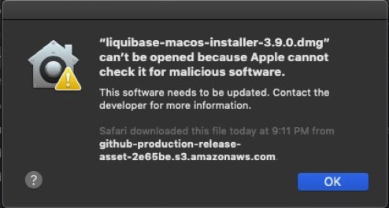

Instead of double-clicking on the installer, right-click on the installer and select Open.

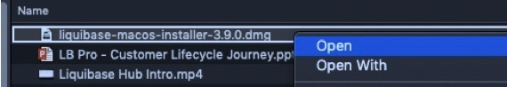

Click the Open button to start the install

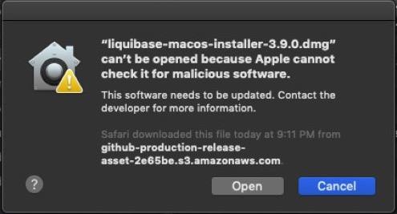

2. Now you should see this install page. Right-click the Liquibase Installer.app file and select Open to begin.

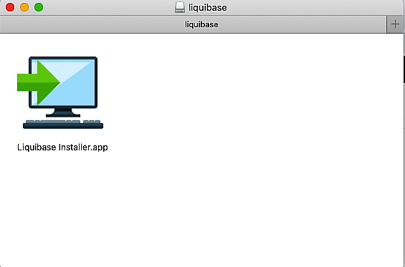

3. Select Next to start the setup wizard.

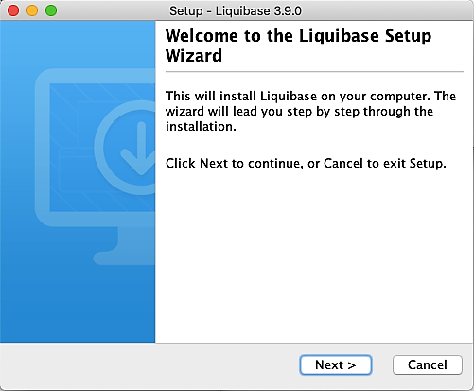

4. Use the default folder /usr/local/opt/liquibase.

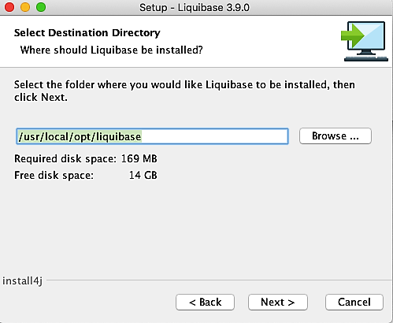

5. Use the default Add Liquibase to PATH.

6. Complete the Liquibase installation by selecting Finish.

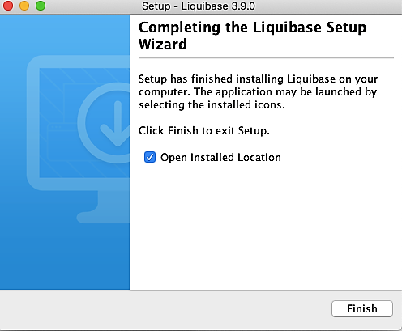

What was installed for Mac

If you selected the default, the Liquibase folder was installed in /usr/local/opt/liquibase and it contains the following directories and files:

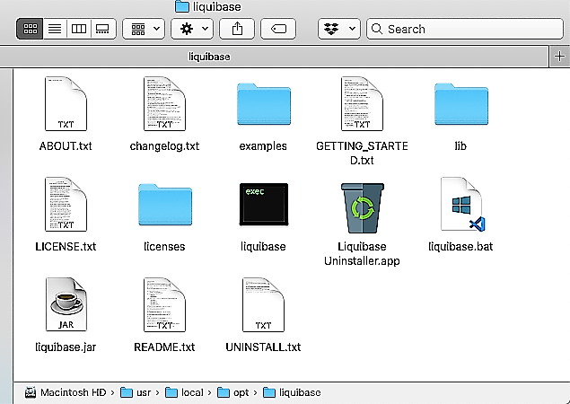

In addition to Liquibase, the following was installed:
- H2 database - The H2 JDBC driver was installed in the examples directory for the H2 database.
- Open JDK - Liquibase installed AdoptOpenJDK open-sourced binaries and scripts.

Congratulations! Liquibase should now be successfully installed. If you are experiencing any problems, please review the troubleshooting tutorial in this module.

Select Complete and continue to learn how to set up your workspace.
Setting up your Windows and Mac Workspace
Now that you have completed the installation of Liquibase on your system, we will review how to set up your workspace. If you used the default directory for your workspace in the Windows or Mac Liquibase installer, you must first copy the example directory to another location on your machine.
This is important for two reasons:
- Depending on your system admin rights, you may not have permission to write to this folder. Copying the folder to another directory will allow for read/write file access.
- It is best practice to copy the example directory to a workspace directory for your project. This will make it easier to create and edit other files, such as changelogs, and manage them in source control.

Example Projects
There are two projects under the examples directory:
- examples/sql directory shows how to use an SQL formatted changelog.
- examples/xml directory shows how to use an XML formatted changelog.
Both projects use the same setup and examples and only differ in the changelog type.

Starting the Example H2 Database
H2 is a standard SQL database and can be used to simulate anything you are required to do in your own database.
- To start the example database, run examples/start-h2 from your command line.
- To stop the example database, use ctrl-c.
Running examples/start-h2 starts a local H2 database that listens on port 9090 and opens a browser to the
database console on the same port.
Note: The example H2 database does not store data and will reset to its starting state when the start-h2
process ends.
The Start-h2 Scripts Starts Two Databases
- A Developer Database: this database is your primary, local database.
- An Integration Database: this database is used as the second database in your pipeline and is useful for commands that require two databases (i.e., diff)
The Console
- The web-based console allows you to see all objects in your database in the left-side navigation and run SQL statements on the right-side view.
- Along the top is a toolbar that includes the Refresh button that can be used to reload the left-side object view. This is important to do if changes are made to your database outside of the console (like with Liquibase) since the console will not refresh automatically.
- The integration database can be viewed in your browser using the link provided in the output of start-h2 script. You can also see which database you are connected to by looking at the URL at the top of the object view.

Perform a Test Run
- Enter create table test_table (id int) in the text area and select Run.
- You should see TEST_TABLE appear in the object view.

Select Complete and continue to learn about installing Liquibase with Maven.
Manual Installation Using Maven
Maven is based on the concept of a project object model (POM) and can manage a project’s build, reporting, and documentation. Before using Maven with your Liquibase projects, it must be installed.

Installing Maven on Mac|Linux|Unix
- Go to https://maven.apache.org/download.cgi.
- Scroll down to the Files section and select the .tar.gz file to download Maven for Linux/Unix/Mac.
  - You can find a complete set of installation directions at https://maven.apache.org/install.html.
- Extract the file to a new local directory on your computer. For example, /usr/apps/apache-maven-3.6.3.
  - Add the maven-version/bin directory to your PATH:
    - Open the Terminal or Linux Command Line.
    - Run the following command: export PATH=$PATH:/usr/apps/apache-maven-version/bin
This command will not permanently update your PATH for the remainder of the session. To permanently update your PATH, edit your ~/.profile or ~/.bashrc and the export command shown above, then run either source ~/.profile or source ~/.bashrc.
- Restart the command line for changes to take effect, then enter mvn -v to verify the installation.

Installing Maven on Windows
- Go to https://maven.apache.org/download.cgi.
- Scroll down to the Files section and select the .zip file to download Maven for Windows.
  - You can find a complete set of installation directions at https://maven.apache.org/install.html.
- Extract the file to a new local directory on your computer. For example, c:\apps\apache-maven-3.6.3.
- Add the maven-version\bin directory to your PATH by running the command set PATH=%PATH%;c:\apps\apache-maven-version\bin on the command line. To permanently add it, perform the following:
  - Go to Search, enter env, and then select Edit the system environment variables.
  - On the Advanced tab, select Environment Variables.
  - In the System variables section, select New, and then add the path to the Maven installation directory c:\apps\apache-maven-version\bin
- Restart the command line for changes to take effect, then enter mvn -v to verify the installation.

Congratulations, Maven should now be successfully installed. If you are experiencing any problems, please review the troubleshooting tutorial in this module.
Setting up Liquibase with Maven

In this tutorial, you will set up Liquibase with Maven and generate an example project. You will learn and apply concepts by creating new Liquibase projects within Maven.

Generate a Liquibase Project with Maven

To generate a Liquibase project within Maven that uses your database, create the following:
- A new project directory and name it Maven<db_type>.
Note: Replace <db_type> with the type of your database.
- A new file named changelog.<db_type>.xml or changelog.<db_type>.sql in the Maven<db_type> directory. This file will be your changelog, a file that keeps track of all the changes you make to your database structure.
Note: Replace <db_type> with the short name of the target database type. These include h2, oracle, postgresql, and mysql.
- A new file in the same directory named liquibase.properties. We will review the information about the changelog and liquibase.properties files in the next tutorials. Alternatively, you can specify all your information within the pom.xml file without including the liquibase.properties file.
- The Maven POM file for the project in the same directory named pom.xml. Our example includes the liquibase.properties file that will have values in it. If you would like to know more details about the pom.xml configuration without the liquibase.properties file, see the Configuring Liquibase Attributes in your Maven POM File documentation.
Edit the pom.xml file and update it to have the following contents:
<project xmlns="http://maven.apache.org/POM/4.0.0" xmlns:xsi="http://www.w3.org/2001/XMLSchema-instance"
xsi:schemaLocation="http://maven.apache.org/POM/4.0.0 http://maven.apache.org/xsd/maven-4.0.0.xsd">
<modelVersion>4.0.0</modelVersion>
<groupId>com.my-group.app</groupId>
<artifactId>Liqui<SampleDb>-app</artifactId>
<version>1.0-SNAPSHOT</version>
<build>
<pluginManagement>
<plugins>
<plugin>
<groupId>org.liquibase</groupId>
<artifactId>liquibase-maven-plugin</artifactId>
<version>3.9.0</version>
<configuration>
<propertyFile>liquibase.properties</propertyFile>
</configuration>
<dependencies>
<dependency>
<groupId><db_type></groupId>
<artifactId><db_type></artifactId>
</dependency>
</dependencies>
</plugin>
</plugins>
</pluginManagement>
</build>
</project>
Note: You can indicate any other version of liquibase-maven-plugin in place of <artifactId>liquibase-maven-plugin</artifactId> <version>3.9.0</version>.

Select Complete and continue to learn about the Java installation.
Java Installation

Liquibase is a Java application and requires Java installed on your machine to run. If you installed Liquibase using the Liquibase Installer, then Java will be installed. If Java is not present, you will need to install it as shown below.

There are two options for installing Java:
- OpenJDK by Oracle - Oracle provides the latest OpenJDK release under the open-source GPL License. (This version of Java was used in the initial installation process using the Liquibase installer). Select jdk.java.net to download and install the latest version.
- Java by Oracle - Oracle provides the latest Java release for all operating systems. Select java.com to download and install the version for your operating system.

Note: Liquibase only supports OpenJDK and Oracle Java.

Select Complete and continue to learn about Troubleshooting Common Installation Issues.
Liquibase Installation Issues

Verifying that Liquibase installed correctly is an essential part of the Liquibase installation process. Here are the three steps to troubleshoot issues with the installation.
- Check the system path - After downloading and installing Liquibase for your operating system, the System PATH variable should indicate the folder location of Liquibase. Verify that the Liquibase folder was correctly added and that the System PATH variable references the correct folder location.
- Check the Java installation - Liquibase will not run without Java. Make sure java is correctly installed on your system by checking version of java installed on your system.
- Check the Liquibase installation - Verify that Liquibase is available and works correctly by running the liquibase help command.

There are different ways to verify that Liquibase installed correctly based on your operating system. We will review the verification for Windows and Mac/Linux using the Command Line (CLI) installation.

Step 1: Check the Path System Variable
- Windows
  - Go to Search, type power, and then select Windows Power Shell.
  - Type $env:PATH and verify the path references the Liquibase installation folder: C:\Program Files\liquibase
  - The following should be returned:
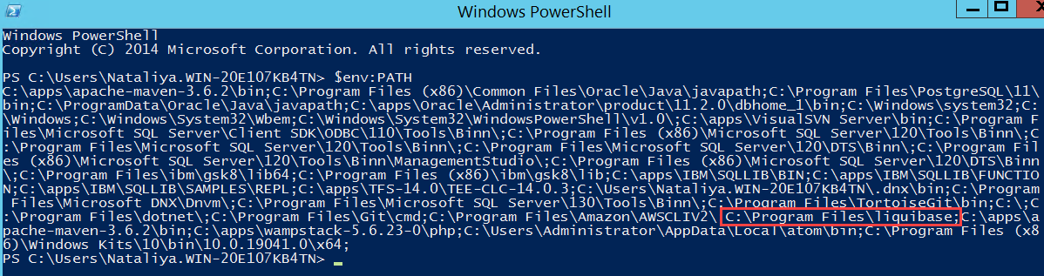
- Mac|Linux|Unix
  - Type env in your Terminal or Linux Command Line to display the contents of your PATH environment variable and verify the path references the Liquibase installation folder: liquibase-<version #>

Step 2: Check the Java Installation
- Windows
  - Open the Command Line and type java.exe -version. If you receive an error message download and install the latest version of Java from Oracle's website.
- Mac/Linux
  - Open your Terminal or Linux Command Line and type java -version.
  - If you see the error -bash: java: command not found then either Java will need to be installed or the location of Java will need to be added to your PATH. You can download and install the latest version of Java from Oracle's website.
If you continue to receive an error message after installing Java, add Java to your Path System Variables.

Step 3: Check the Liquibase Installation
Running the help command depends on the correct installation of Java.
- Windows
  - Open the Command Line and type liquibase --help.
- Mac
  - Open your Terminal or Linux Command Line and type liquibase --help

If you installed Liquibase with Maven on a Mac|Linux|Unix machine, the steps are very similar.

Step 1: Check the Path System Variable
Verify that the maven-3.6.2/bin folder was added correctly to your PATH, type env in your Terminal or Linux command line.

Step 2: Check for Java Installation
- Open your Terminal or Linux Command Line and type java -version.
- If you see the error -bash: java: command not found then either Java will need to be installed or the location of Java will need to be added to your PATH. You can download and install the latest version of Java from Oracle's website.
If you continue to receive an error message after installing Java, add Java to your Path System Variables.

Step 3: Run Maven
- Open your Terminal or Linux Command Line and type mvn -v to verify the information is correct.
- The following should be returned:
Apache Maven 3.6.2 (40f52333136460af0dc0d7232c0dc0bcf0d9e117; 2019-08-27T17:06:16+02:00)
Maven home: /opt/apache-maven-3.6.2
Java version: 1.8.0_45, vendor: Oracle Corporation
Java home: /Library/Java/JavaVirtualMachines/jdk1.8.0_45.jdk/Contents/Home/jre
Default locale: en_US, platform encoding: UTF-8
OS name: "mac os x", version: "10.8.5", arch: "x86_64", family: "mac"

Select Complete and continue to learn about Configuring Liquibase.
Liquibase Configuration
To start exploring Liquibase, you need to learn about the liquibase.properties file.
This is a text-based file that is either created automatically during the Windows and Mac|Linux|Unix installer process or manually when you choose another installation option. This file stores properties that are used frequently and do not change often. The most useful properties are the database connection information.
Using the liquibase.properties file saves you time and potential typing errors by removing the need to enter these properties as command line arguments.

Let's review the most common properties.

Liquibase Properties
Inside the liquibase.properties file, there are several key properties that you can set. If you set the values in the liquibase.properties file, then the values do not need to be specified on the command line each time you run a command.
Different commands require different properties to be specified. Common properties include:
changeLogFile | The path for your changelog file.
driver | The driver class name for your target database.
url | This parameter is the target of the action (target database).
username | The username for your target database.
password | The password for your target database.
referenceDriver | The driver class name for your source database.
referenceUrl | The starting point or source database that is the basis for the comparison.
referenceUsername | The username for your source database.
referencePassword | The password for your source database.
classpath | The path for your database driver.
For Liquibase Pro users, setting the liquibaseProLicenseKey eliminates the need to include the license key on every Liquibase command. Any property listed in the liquibase.properties file can be overridden as a command line argument to the CLI.

Note: While Liquibase allows for user authentication information to be stored in the liquibase.properties file, it is recommended that user credentials are stored in a secure credential repository, or entered in the CLI when running a command.

Select Complete and continue to Activity 1: Create or Edit a liquibase.properties File.
Activity 1: Create and edit the liquibase.properties file:

Step 1: Create the liquibase.properties text file in the directory where you have related changelogs. If you use the liquibase.properties file that was created earlier in the tutorial, you may skip this step.

Note: You have the option of choosing a different filename for the liquibase.properties file. However, using a different filename requires that you reference it with the --defaultsFile attribute every time you run a Liquibase command.

Step 2: Edit the liquibase.properties file. Type the property key (driver, changeLogFile) and property value for each of the desired properties. Please refer to the Liquibase Documentation for more information on setting up the liquibase.properties file.

Note: The best practice is to configure the liquibase.properties file to include your driver classpath, and URL information for the database you want to capture. This is one of the ways for Liquibase to connect with your database. For Liquibase Pro users, you will enter your license key in the liquibaseProLicenseKey area as shown in the example below.

If you use the H2 database and a sample liquibase.properties file, all the values are already specified there, however, if you use DEV or TEST database and a sample liquibase.properties file, you can enter your values instead.

Here is an example:

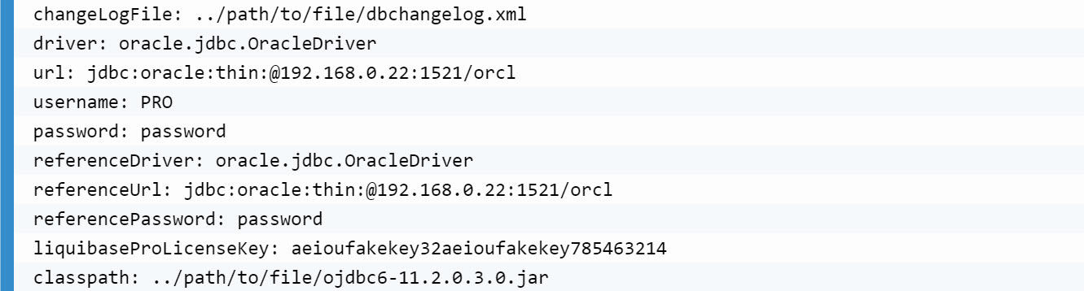

Step 3: Save the liquibase.properties file and exit.

Complete the activity by recording a video of the liquibase.properties file, or take a screenshot and upload the image to this activity for credit.

Note: Do not upload a copy of the actual file. Do not select the Record Video button to record a video. Use your preferred screencast program instead.

Next Up: Module 1 Knowledge Check.

